SCHOOL OF COMPUTING, ENGINEERING, AND DIGITAL
TECHNOLOGIES


Al Tutor / Study Companion Chatbot

MSc Artificial Intelligence
Module Code: CIS4006-N
Student Full name- Rohit Raj Mahendrakar
Student ID-S3399337
Supervisor’s name- Alessandro Di Stefano
Wordcount: 3020

Table of Contents
1. Introduction 3
1.1 Purpose 3
1.2 Project Overview 3
1.3 Target Job Role 3
1.4 Reflection Model 3
2. Activities 4
2.1 Interface Design and Wireframing 4
2.2 Registration and Login Interfaces 5
2.3 Chat Interface Implementation 6
2.4 Integration with Backend API 7
2.5 UI Testing and Optimization 7
2.6 Outcome 8
3. Contribution 8
3.1 Alignment with System Objectives 8
3.2 System Integration and Collaboration 8
3.3 Usability Enhancements 8
3.4 Accessibility and Inclusivity 9
3.5 Overall Impact 9
4. Reflection 9
4.1 Application of Driscoll’s Model 9
4.1.1 What? 9
4.1.2 So What? 10
4.1.3 Now What? 10
4.2 Challenges and Resolutions 10
4.3 Reflection Summary 10
5. Personal Benefits 10
5.1 Technical Growth 10
5.2 Project Management and Teamwork 11
5.3 Professional and Ethical Awareness 11
5.4 Personal Development 11
5.5 Summary 11
6. Professional Values 11
6.1 Accountability 11
6.2 Integrity 12
6.3 Respect for User Trust and Accessibility 12
6.4 Reflection on Professional Conduct 12
7. References 13

1. Introduction

1.1 Purpose
This reflective report is aimed at critically reflecting on the experience of an internship that I completed as a Frontend Developer and was working on a knowledge-retrieval and AI-based tutoring platform. The report recalls the things I had experienced, the obstacles I had to withstand, and the learning outcomes that I had earned during the period of the internship. Instead of a straightforward report, the present report is more of a personal and professional experience report, as it underlines how the experience helped me understand how frontend development can be applied in AI-powered systems.
The internship project consisted of creating an interactive chat-based tutoring system, which was able to use Retrieval-Augmented Generation (RAG) methods in generating transparent and explainable responses to the users. My job mandated me to work with intricate back-end logic and artificial intelligence, resulting in a user interface that was easy to navigate, user-friendly, and credible.

1.2 Project Overview
The internship project centered on the creation of a modular and transparent AI tutoring system to respond to the queries of the users using curated datasets whe. In the information was not available, the fallback response was provided by large language models like Gemma and DistilGPT-2. One of the aims of the project was to ensure transparency in responses that are generated by the AI so that the users could comprehend the origin of the information presented. Although the team of backend software developers and QA engineers was in charge of retrieval logic and hallucination control, as well as system evaluation, my focus was on the design and implementation of the frontend interface. My role was to make sure that users were able to seamlessly, safely, and comprehensively communicate with the AI tutor.
This entailed working hand in hand with the backend developers in order to incorporate APIs and portray system behaviour correctly in the interface. The ultimate frontend system had three major components. The former was a registration page, where users were able to make secure accounts with proper validation and feedback messages. The second one was a login page, which would help in implementing secure authentication and session persistence.

1.3 Target Job Role
After obtaining my Master's, my future profession is to be a Frontend Engineer in AI-based systems. The internship was also significant in helping me towards this objective as I was able to put my theoretical knowledge to practical, professional practice.
I gained and enhanced essential skills needed in this position during the internship. These were hands-on work on responsive web development based on HTML, CSS, and JavaScript, and a better knowledge of the principles of the UI/UX and accessibility. Another aspect that I learned is exposure to working with Flask-based applications and RESTful APIs, which boosted my performance in working in a complete stack development team.

1.4 Reflection Model
This report applies the Driscoll Model of Reflection in order to facilitate structured and critical reflection, and it is anchored on three guiding questions, namely, What, So what, and Now what? This model gives a very transparent and systematic approach to reviewing professional experiences and learning outcomes.
What? Stage the stage with the description of activities and the circumstances experienced in the course of the internship. So what? Step increases the level of analysis by asking about the meaning of these experiences, having difficulties, acquiring skills, and getting drawings. Lastly, Now what? The stage facilitates future-focused thinking by reflecting on the way the internship experience will shape my future professional practice and development.

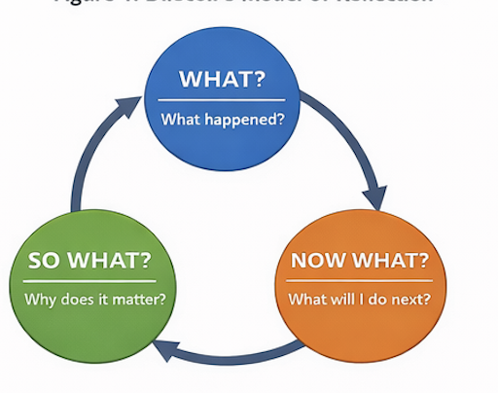

Figure 1. Driscoll’s Model of Reflection” diagram here

2. Activities
Activities that I performed as a Frontend Developer were organized in several development cycles, in accordance with the sprint plan developed by the team and the system architecture. My activity involved the strict cooperation with the backend and QA teams to make sure that there was coherence between the Flask-based backend, the RAG pipeline, and the user-facing interface.

2.1 Interface Design and Wireframing
The design of the overall UI layout and the navigation of the tutoring system was one weremy first tasks. Figma was used to generate wireframes of the Register, Login, and Chat pages based on the principles of clarity, minimalism, and alignment with the system transparency-based learning goal. The designs were discussed at the weekly meetings with the team lead and backend developer where t, where he technical feasibility was assessed, and system requirements met.
Key design goals included:
- Highlighting indicators of trust, e.g., source labels to dataset-based, uploaded, or model-generated responses.
- Creating a clean chat interface that distinctly separates user and system messages.
- Providing the responsiveness of various devices and screen sizes.

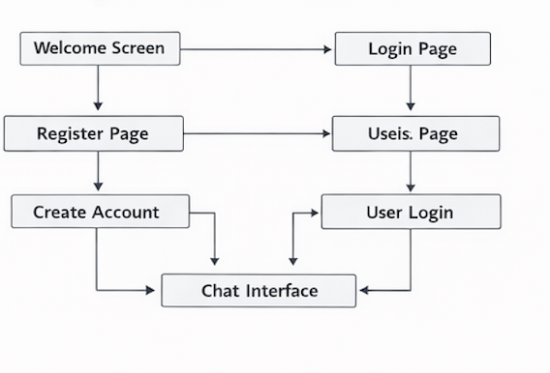

Figure 2 Wireframe flow that was followed during the frontend implementation.

2.2 Registration and Login Interfaces
After wireframes were approved, I incorporated the registration and login interfaces with HTML, CSS, and the Jinja2 templating engine of Flask. The registration page enabled new users to create an account that validated the form with contextual error correction, and the login page enabled secure authentication with session preservation.
Semantic HTML elements and logical structure of headings and ARIA labels have been used wherever possible in order to make the site more accessible. These interfaces were accessed by using dynamic Flask routes (/register, /login) so that failure and success messages could be conditionally rendered and a seamless user experience could be ensured.
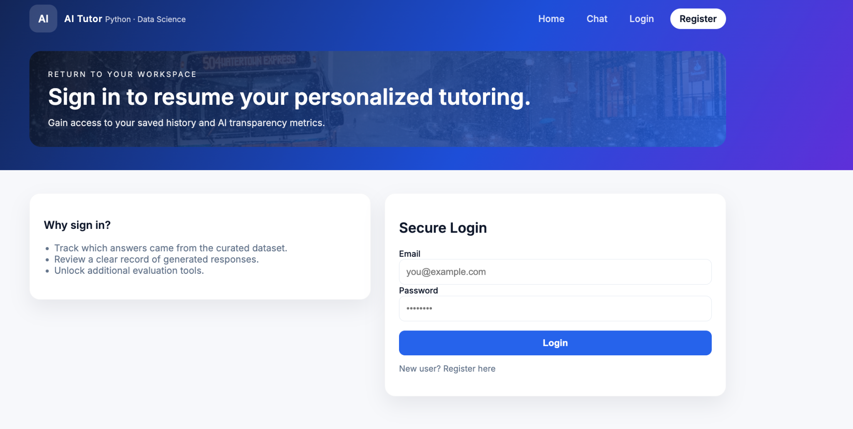

Figure 3. Register & Login Interface

2.3 Chat Interface Implementation
The front-end was built around the chat interface, achieved by use of the chat.html which w, as the key point of interaction between the users and the AI tutor.
Some of the major features that I implemented are:
- The display of messages that visually separates those posted by users and those posted by tutors.
- There should be a transparency legend of four types of response to the Dataset Answer, the Uploaded File Answer, the Generated Answer, and the Low Confidence.
- The ability to add new knowledge to a file upload system (.txt, .csv, or .md).
- Status monitoring, including real-time monitoring of the system status through the /status endpoint, to notify the users of the system's readiness.
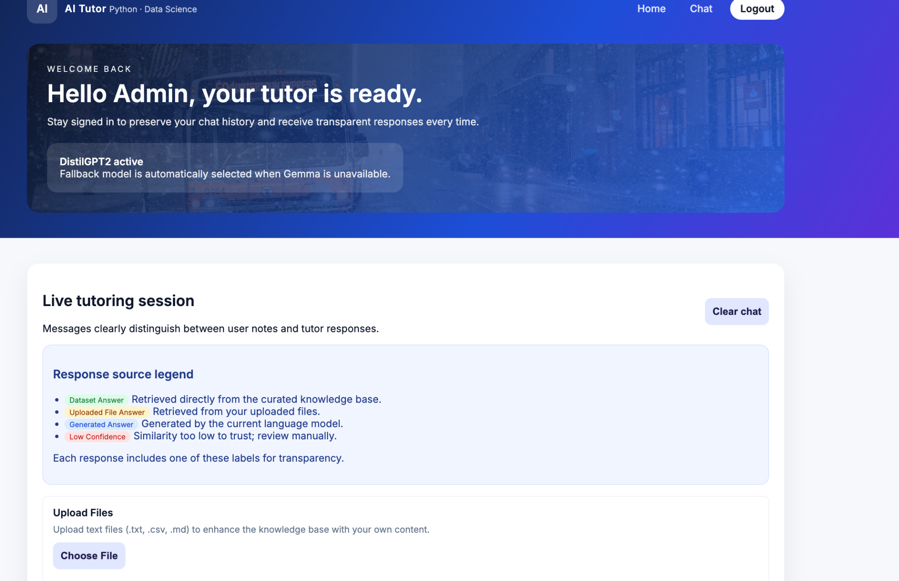

Figure 4. Chat Interface

2.4 Integration with Backend API
In order to interface the frontend and the backend services, I cooperated with the Backend Developer to create API endpoints to submit chat, upload files, and get status. I used the Fetch API of JavaScript to support asynchronous POST and GET requests and react to the dynamically changing chat interface, using JSON format to respond to a request.
For example:
- Chat queries are posted on the/chat endpoint.
- /upload is used to handle file uploads.
- System readiness is tested through /status.

2.5 UI Testing and Optimization
I performed manual and automated testing on the UI on Chrome DevTools and Lighthouse audits to verify the existence of:
- Optimization of performance (rendering efficiency and load time).
- Accessibility enhancements (color contrast, can use the keyboard).
- Multidimensional responsiveness.
The cooperation with the QA Engineer was necessary to ensure that all the frontend details were matched with the test cases (e.g., the transparency label display and upload button enabler functionality was properly checked).

2.6 Outcome
By the completion of this step, the frontend system had visual coherence and consensus with the ethical goals of the project, regarding transparency and accessibility. The users could register, authenticate, and talk to the AI tutor and clearly receive the source and the degree of confidence of each response, which justified trust in AI-based interactions.

3. Contribution

3.1 Alignment with System Objectives
My main contribution as a Frontend Developer was that the ency-first philosophy of the system was well represented in the user interface. The AI tutor was not only meant to give answers but reveal the source of the answer, which I accompanied with colour-coded labels and visual cues in the chat interface.

3.2 System Integration and Collaboration
During the development, I worked hand in hand with the Backend developer and QA engineer to facilitate a smooth period of integration.
- I also liaised with the backend team to establish chat interaction points, data upload points, and system status retrieval points.
- I assisted in debugging asynchronous calls so that the return of the JSON would be properly rendered without freezing the interface.
- The I and the QA Engineer ran the tests repeatedly to ensure that the indicator called Low Confidence would be activated during the situations of uncertainty retrieval.
- This system testing cycle enhanced the stability of the system and reduced confusion among the users when the data is latent or the model is unavailable.
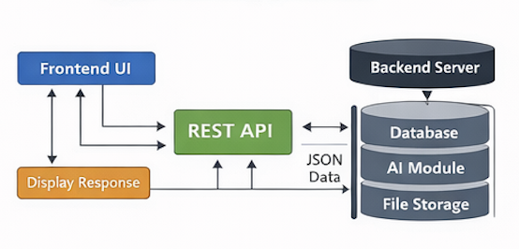

Figure 5. Frontend–Backend Communication Flow Diagram

3.3 Usability Enhancements
I made a few usability enhancements to improve the user experience (UX) and minimize friction:
- Extra live validation for the registration and login form to give immediate feedback.
- Added a Suggested Prompts area to the chat window that enabled new users to learn the system features without having to be taught.
- Introduced visual feedback ( loading messages, color-coded status alerts ) to minimize the uncertainty in cases when the backend services were starting up.
- Facilitated a file-upload system to enlarge the knowledge base in real-time, facilitating user autonomy.

3.4 Accessibility and Inclusivity
The issue of accessibility was solved with the help of semantic HTML and ARIA attributes, as well as the manual verification of keyboard navigation and colour contrast. Such steps were made to make sure that the interface would be usable by a broad spectrum of users and that it would comply with the principles of inclusive design.
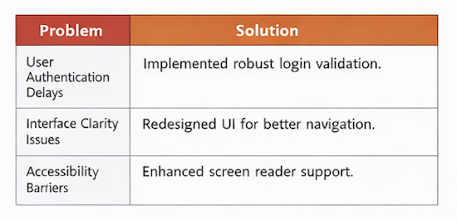

Figure 6. Accessibility Testing Overview

3.5 Overall Impact
My involvement made sure that the technical functionality of the system was converted into a non-hazy and reliable user experience. The frontend served as a bridge to make the processes of the complex AI communicated in a way that anyone could understand, which supports the idea of the system being a trusted educational companion.

4. Reflection

4.1 Application of Driscoll’s Model
This is done by following the reflective framework of Driscoll (What? So what? Now What?), I examined some of the experiences and lessons that I have gained during the internship.

4.1.1 What?
The internship involved me creating the entire front end of the tutoring system, i.e., registration, authentication, and the live chat interface. First, I had under-estimated the complexity of real-time interaction management and the UI synchronization with the backend response. Certain unrelated and asynchronous tasks resulted in a message being sent twice or a freezing moment. Also, visual clarity and presentation of multiple sources of responses necessitated a number of UI redesigns.

4.1.2 So What?
Over time, I learnt how to resolve latency problems in frontend communication through constant teamwork and resolve them. By combining with Fetch API and using suitable patterns of a promise with an await statement, I was able to solve concurrency issues that had led to inconsistent message displaying before.
I also learned more about ethical design and the fact that visual transparency should be prioritized over technical accuracy in AI systems. Indicatively, a positive response to color-coded labels of source increased the levels of trust of the users, which was consolidated by a positive response to the system testing by the teams. My communication and coordination skills were also enhanced at this stage. The frequent meetings with members of the backend and QA increased my awareness of the dependency and significance of integration testing in a system.

4.1.3 Now What?
The reflection supported some of the long-term learning outcomes:
- Frontend logging and analytics are features that I will include in the next project to gauge user engagement and error rates more efficiently.
- To better manage more complicated dynamic states in future AI-based systems, I will improve my understanding of React.js and Vue.js.
- Another goal of mine is to institutionalize a UI testing plan with automated tools like Selenium or Cypress, so as to guarantee scalability and maintenance.

4.2 Challenges and Resolutions
Through the internship, I faced a number of challenges that needed technical problem-solving as well as reflective adaptation. Among the core challenges, there ato deal with the error/latency in asynchronous frontend-backend communication. The lag in API response sometimes resulted in repeated messages or the freezing of interfaces, and this had adverse impacts on users.

4.3 Reflection Summary
As a whole, this internship helped me a great deal in developing my technical ability as well as professional awareness. It strengthened the necessity of frontend engineering being a key interpreter between the complex AI systems and final users. My understanding of how ethical AI design, in particular, transparency and accountability, can promote and improve has led me to realize that good design is not only about appearance. Good frontend design should be transparent, truthful, and accountable, especially where presentation of AI output is involved.

5. Personal Benefits

5.1 Technical Growth
The internship also helped me grow as a professional in terms of technical growth as a frontend developer. I enhanced my skills in integrating frontend interfaces and backend APIs and handling asynchronous data flows dependably. My skills in HTML, CSS, and JavaScript have evolved, specifically in dealing with real-time interaction and the creation of dynamic content.

5.2 Project Management and Teamwork
My experience in a multidisciplinary team has shown the significance of communication and coordination. I was also involved in sprint reviews and planning sessions that enhanced my knowledge of dependencies and delivery schedules of tasks.
One of my most important learning experiences was being able to adjust frontend workflows to constrain nts of the backend. As an example, after having kw long indexing of files takes I corre, I corrected the upload interface to handle the user expectations better. The experience enhanced my sensitivity to cross-functional dependencies and made me a more qualified design decision maker in a team development setting.

5.3 Professional and Ethical Awareness
One of the biggest personal advantages of the internship was the enhancement of a greater moral duty towards AI system design. Transparency was not considered a cosmetic attribute, but as a professional requirement for users.
The interface has conveyed the truth and responsibility of the human-AI relationship by vividly showing the source and reliability of AI answers. This experience helped me form values of clarity, accessibility, and trust in the user as my professional principles, which I will strive to apply in future projects.

5.4 Personal Development
Other than technical skills, the internship helped with substantial personal development. I was also confident in dealing with end-to-end frontend development, and my problem-solving skills were enhanced thanks to dealing with asynchronous systems, and I am more skilled in communicating what is technical to non-technical stakeholders.
There was also an increase in time management, especially in the harmonization of design cycles, testing, and integration work among weekly sprint requirements. Consequently, I can now feel more equipped to deal with complicated projects both in academics and at work.

5.5 Summary
Altogether, the frontend developer internship helped me to deepen my technical background, hone my design thinking, and get a clear sense of ethical accountability in the development of AI systems. The experience was more than pure technical success and helped develop a more profound sense of user empathy, transparency, and responsibility, the attributes necessary to develop trustworthy AI-based software.

6. Professional Values
During the internship, I always aimed at maintaining the professionalism required of computing practitioners. This section is a reflection of how I showed accountability, integrity, and consideration of user trust and accessibility, as it is provided in ethical principles that are advocated by the British Computer Society (BCS).

6.1 Accountability
The responsibility was the focal point as a frontend developer on a live AI tutoring system. Tasks I had involved close attention to the way AI outputs were displayed to users and the interface behaviour reflectively displayed system states.
My responsibility was to hold myself accountable and monitor changes in the interface using version control, communicate with the rest of the backend and QA team to provide appropriate system feedback, and describe design decisions as they were discussed during the sprint review.

6.2 Integrity
The concept of integrity also informed my decision to make sure that the interface relayed accurate information to the user that is truthful. Bad visual design in AI systems may bias the user and cause a lack of trust.
I used integrity by making a clear distinction between retrieved, uploaded, generated, and uncertain responses with the use of visual signs. No limitations were hidden behind the interface, as they clearly indicated uncertainty when confidence was low or when data was not available. This candid expression conforms with the principle of honesty and professional integrity of acting in the BCS.

6.3 Respect for User Trust and Accessibility
The third professional value that I utilized was respect, namely, the respect for the trust of users, the privacy, and accessibility of the data. Accessibility is a technical and ethical necessity in contemporary software design. I made sure that every frontend page, Register, Login, and Chat, was made to be usable by a large audience through the application of:
- Assistive technology ARIA labels and semantic HTML structure.
- Dark and light themes with high contrast colors to read.
- Buttons and forms that are navigated using a keyboard, and having limited mobility.
- Correct error messages and point information on all input fields.

6.4 Reflection on Professional Conduct
These three professional values of accountability, integrity, and respect were the three ethical principles that steered my work throughout this internship.
- Not only did they change my technical choices, but they changed my professional identity, too.
- I understood that the role of a frontend developer does not focus on the execution of code but on bridging trust between humans and machine intelligence.
- All design choices, including ng color, label, or icon, can influence how users perceive AI trustworthiness and prejudice.
To carry out future roles, I will use the following professional standards:
- Carrying out user experience audits in terms of ethical transparency.
- Working hand-in-hand with backend and data teams to guarantee fair reporting of AI confidence.
- Ensuring that accessibility is tested in every project of mine.

7. References
BCS Code of Conduct. (2023). Professional Conduct and Ethical Guidelines for Computing Professionals. British Computer Society.
Driscoll, J. (2007). Practising Clinical Supervision: A Reflective Approach for Healthcare Professionals. Elsevier Health Sciences.
Nielsen, J. (1994). Heuristic Evaluation of User Interfaces. In Proceedings of the SIGCHI Conference on Human Factors in Computing Systems. ACM Press.
Norman, D. A. (2013). The Design of Everyday Things. Revised and Expanded Edition. Basic Books.
W3C. (2022). Web Content Accessibility Guidelines (WCAG) 2.2. World Wide Web Consortium (W3C).
Flask Documentation. (2024). Templating with Jinja2 and Asynchronous Data Handling. Python Software Foundation.
Google Developers. (2023). Chrome DevTools and Lighthouse Accessibility Audits. Google Web Docs.
Kamuni, A. K. (2023). Glaucoma Detection Using Machine Learning Modelling. Advanced Practice Reflective Report, Teesside University.
University of Teesside. (2024). Advanced Practice CIS4006-N Report Guidance. School of Computing, Engineering & Digital Technologies.
Team Project Documentation. (2024). Retrieval-Augmented Generation Pipeline Overview. Internship Technical Folder.
Krug, S. (2014). Don’t Make Me Think, Revisited: A Common Sense Approach to Web Usability. New Riders.

